Unit 3 – Autocomplete

In this lesson, we will be looking at how we can help our users complete forms quickly and efficiently. Many of you have probably been entering text in an online form and an autocomplete feature enables and displays a list of possible values that you may want entered. Today, we are going to look at how to implement something like that in our applications.

Open the AutocompleteDemo.html and add a new paragraph tag after the first and last name paragraphs.

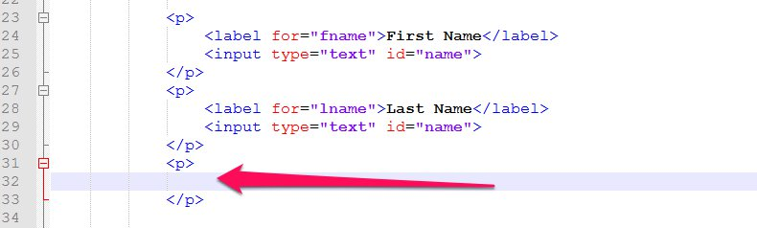

As in most form inputs, we want to start with a label so that the user knows what data we are looking for. In this demo file, we are creating an application to get driver information. So, after the user enters first and last name, we want to know the make of their vehicle. So, let’s add a label for the input that we will create.

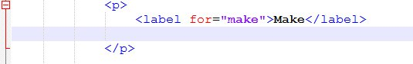

Now that we have our label, let’s create our data type. The data type for this autocomplete will actually be just a text input. However, we will add a list attribute because we will be linking this input to a list of autocomplete options.

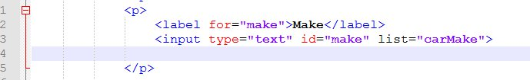

The next task is to add the list of options. We do this with a datalist tag.

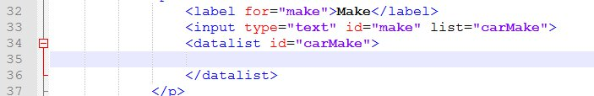

Now we can add the options themselves using option tags. Let’s add a list of possible vehicle makes.

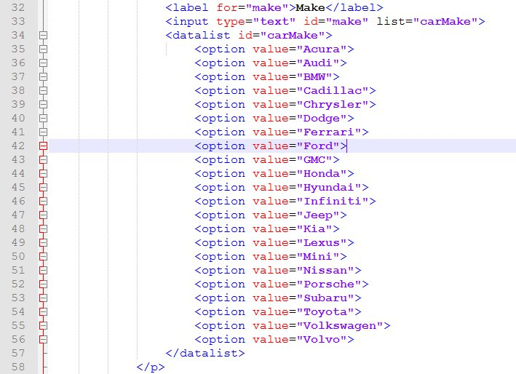

When the user starts to type the make of their vehicle into the application, they will be shown a list of possible options. They can then click on one of the options to autocomplete the field.

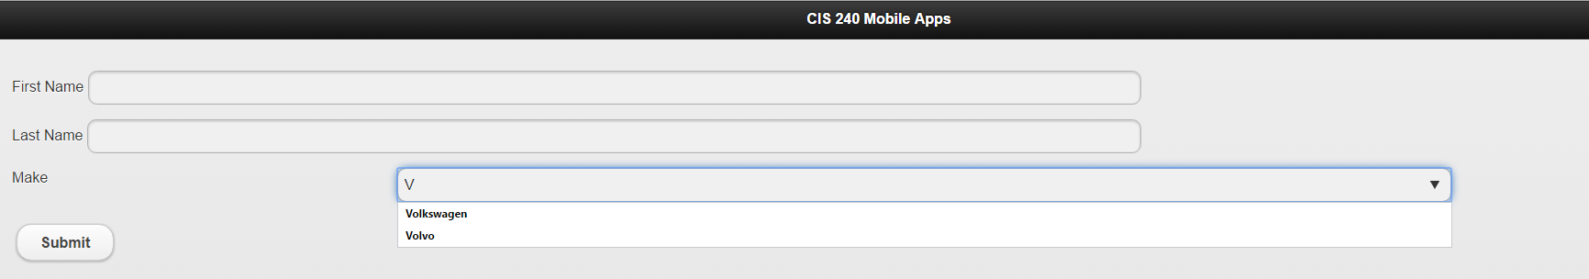

Use this autocomplete input type to complete your Autocomplete Assignment on Portal.